**Python programming**

**Lab 2**

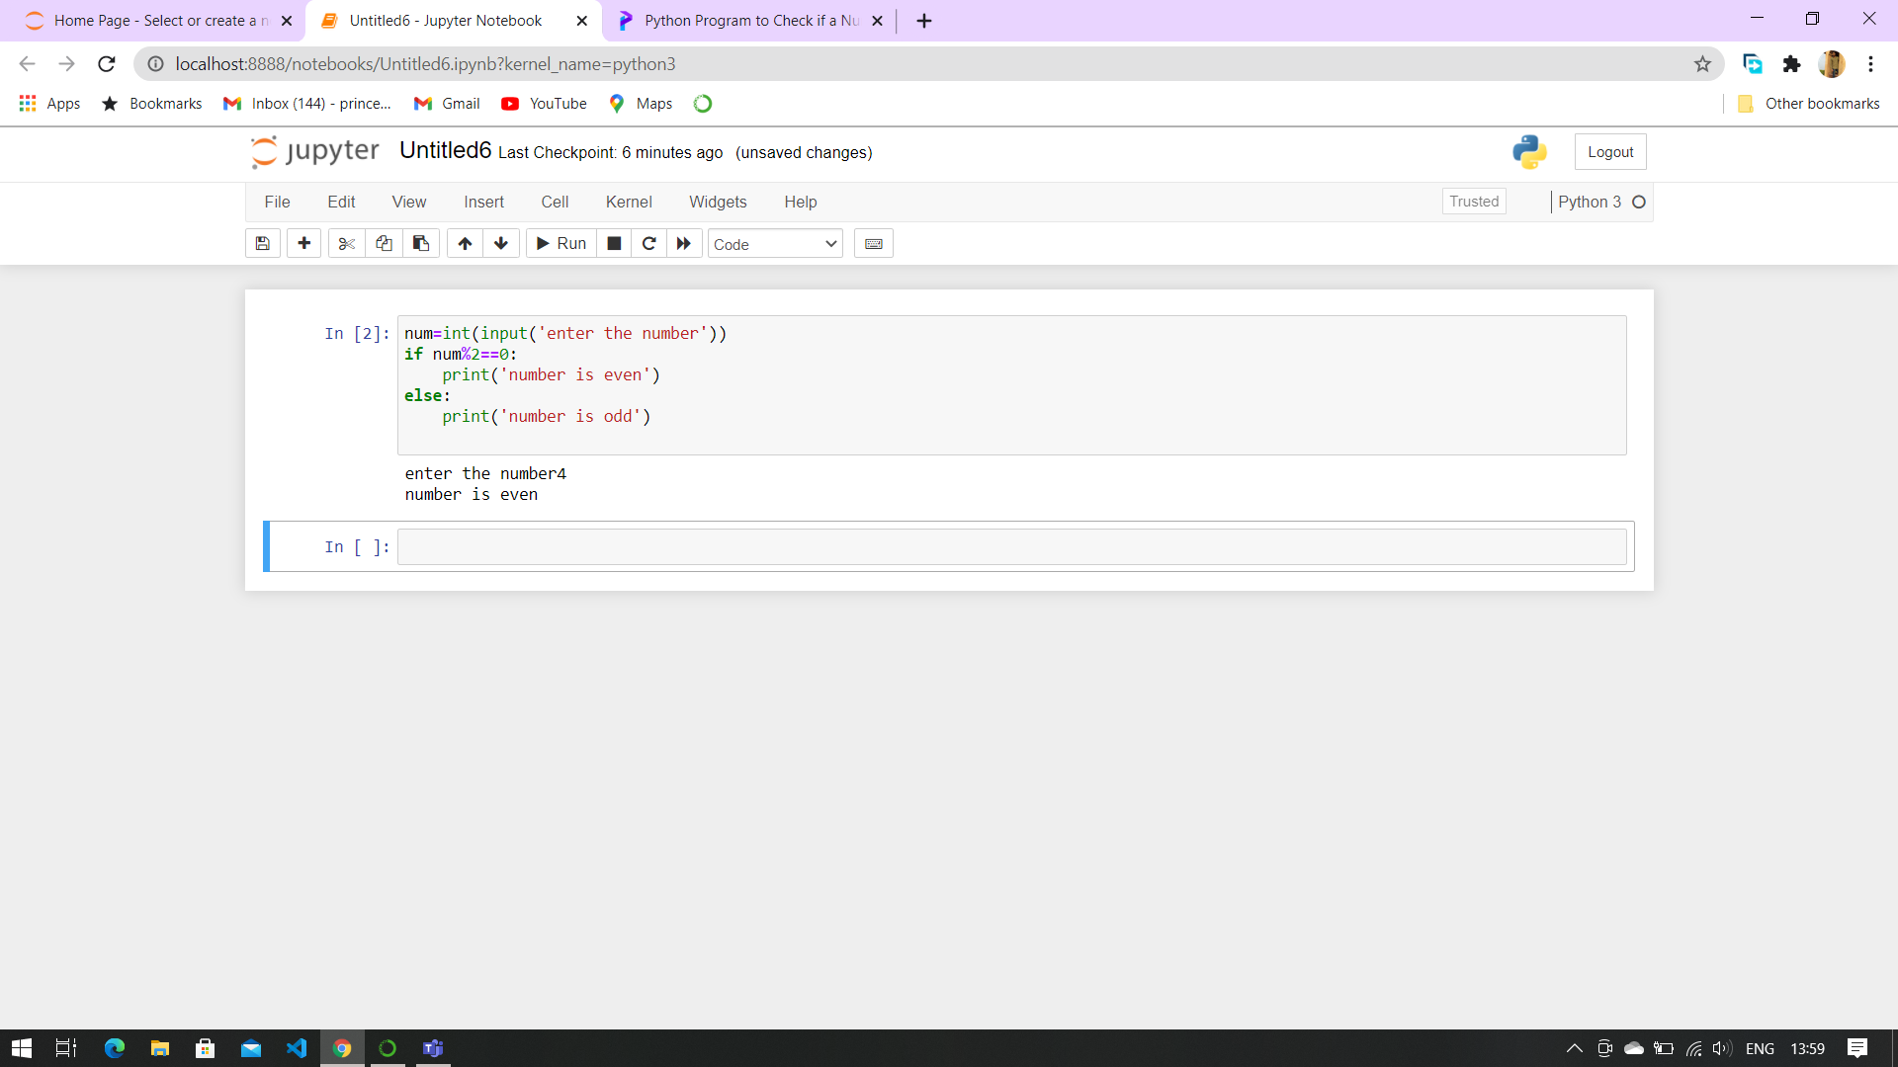1.[Check whether a number is even or odd](https://www.programiz.com/python-programming/examples/prime-number)

2. [Check whether an entered year is leap year or not.](https://www.programiz.com/python-programming/examples/prime-number)

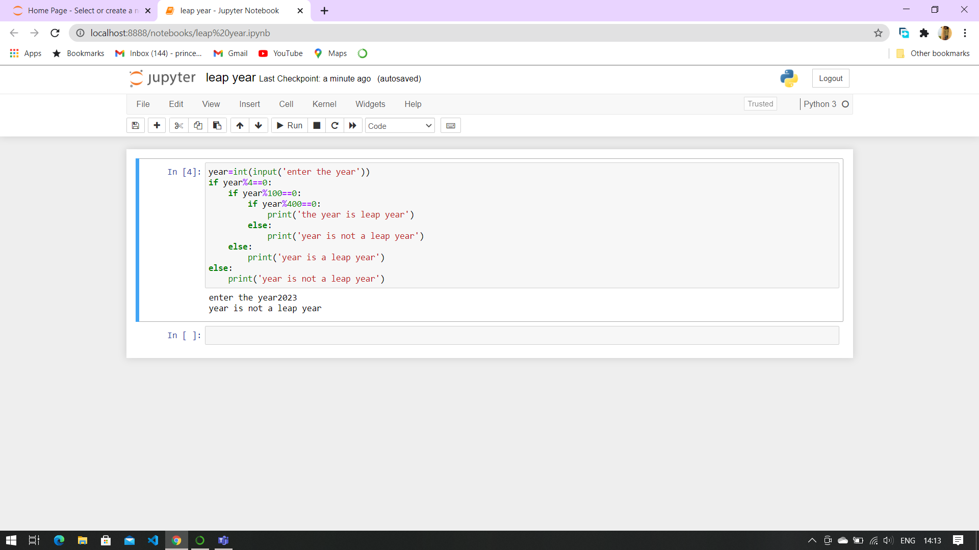

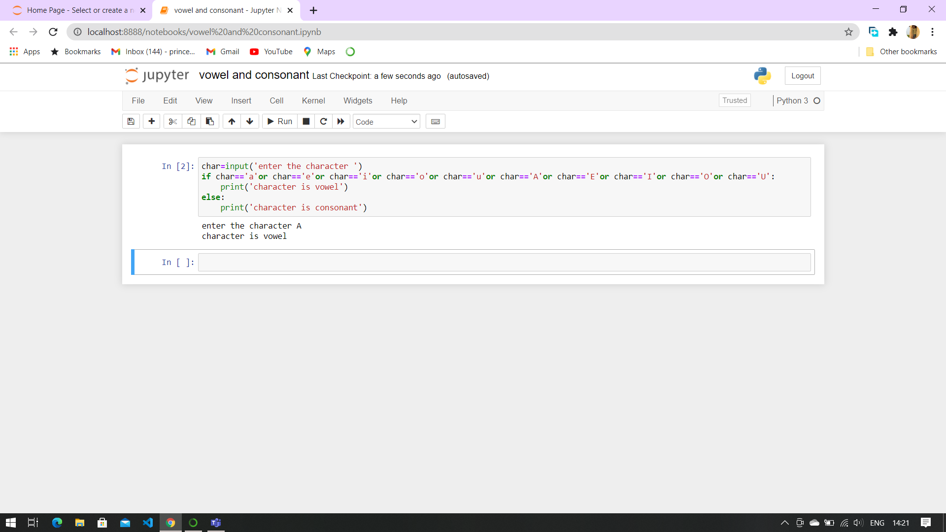3.Write a program to check whether a character is vowel or consonants.

4.Write a program to find the smallest of two numbers.

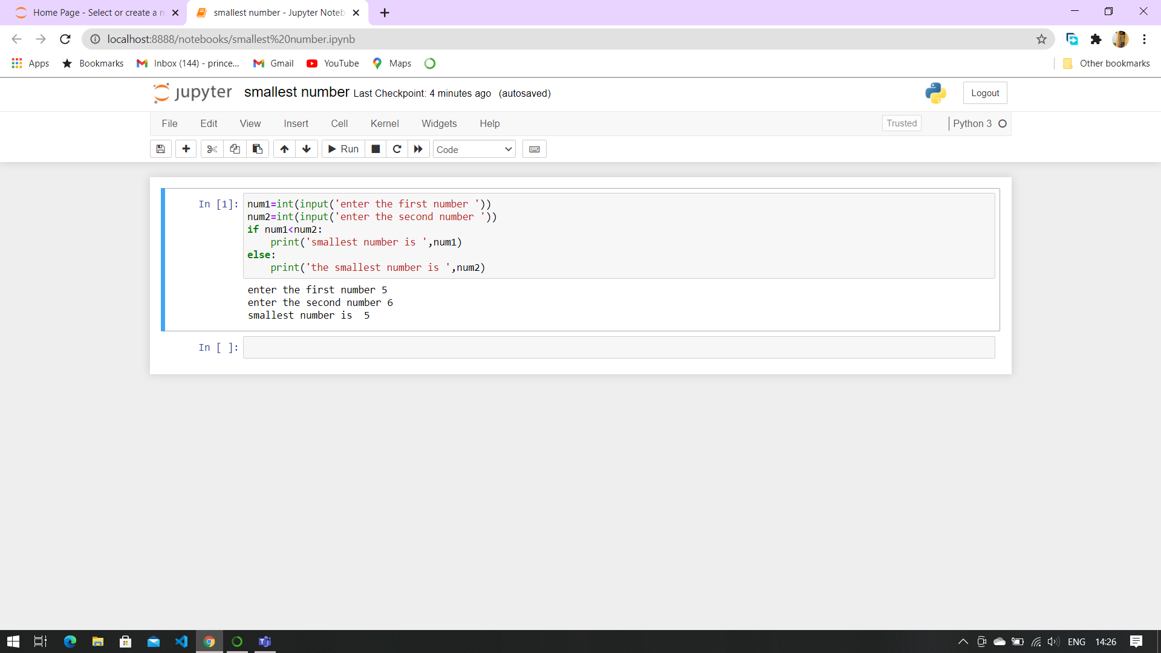

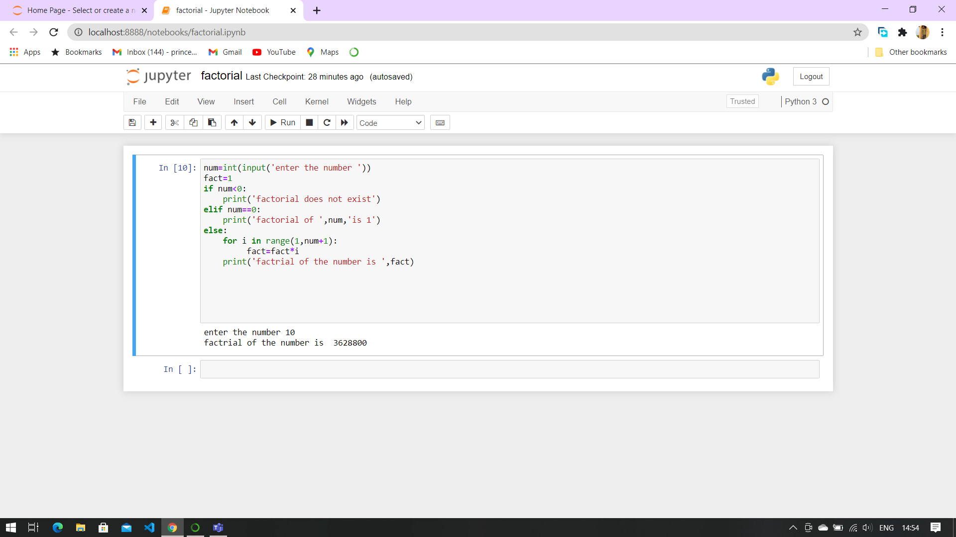5. [Find the Factorial of a Number](https://www.programiz.com/python-programming/examples/factorial)

6.Write a program to print this patterns

         *

     *     *

  *    *     *

         *   *     *     *

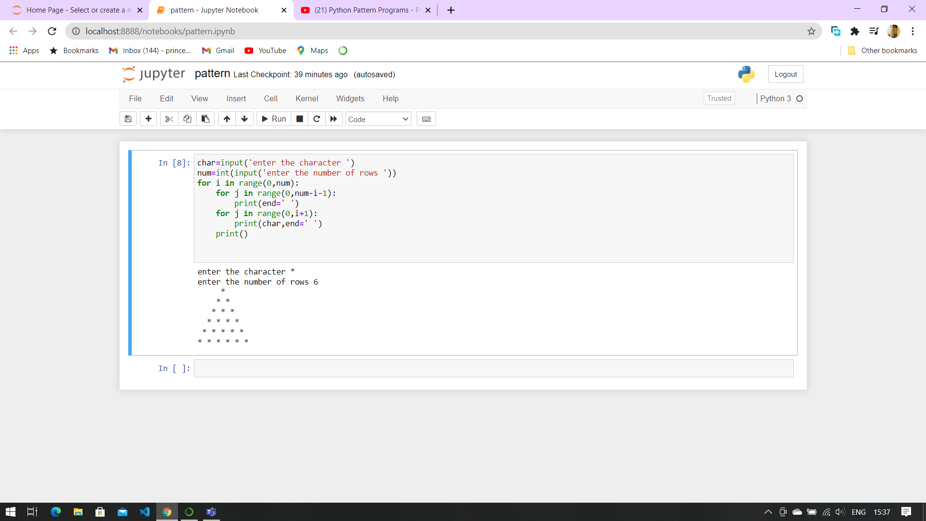

7.Write a program to print this series

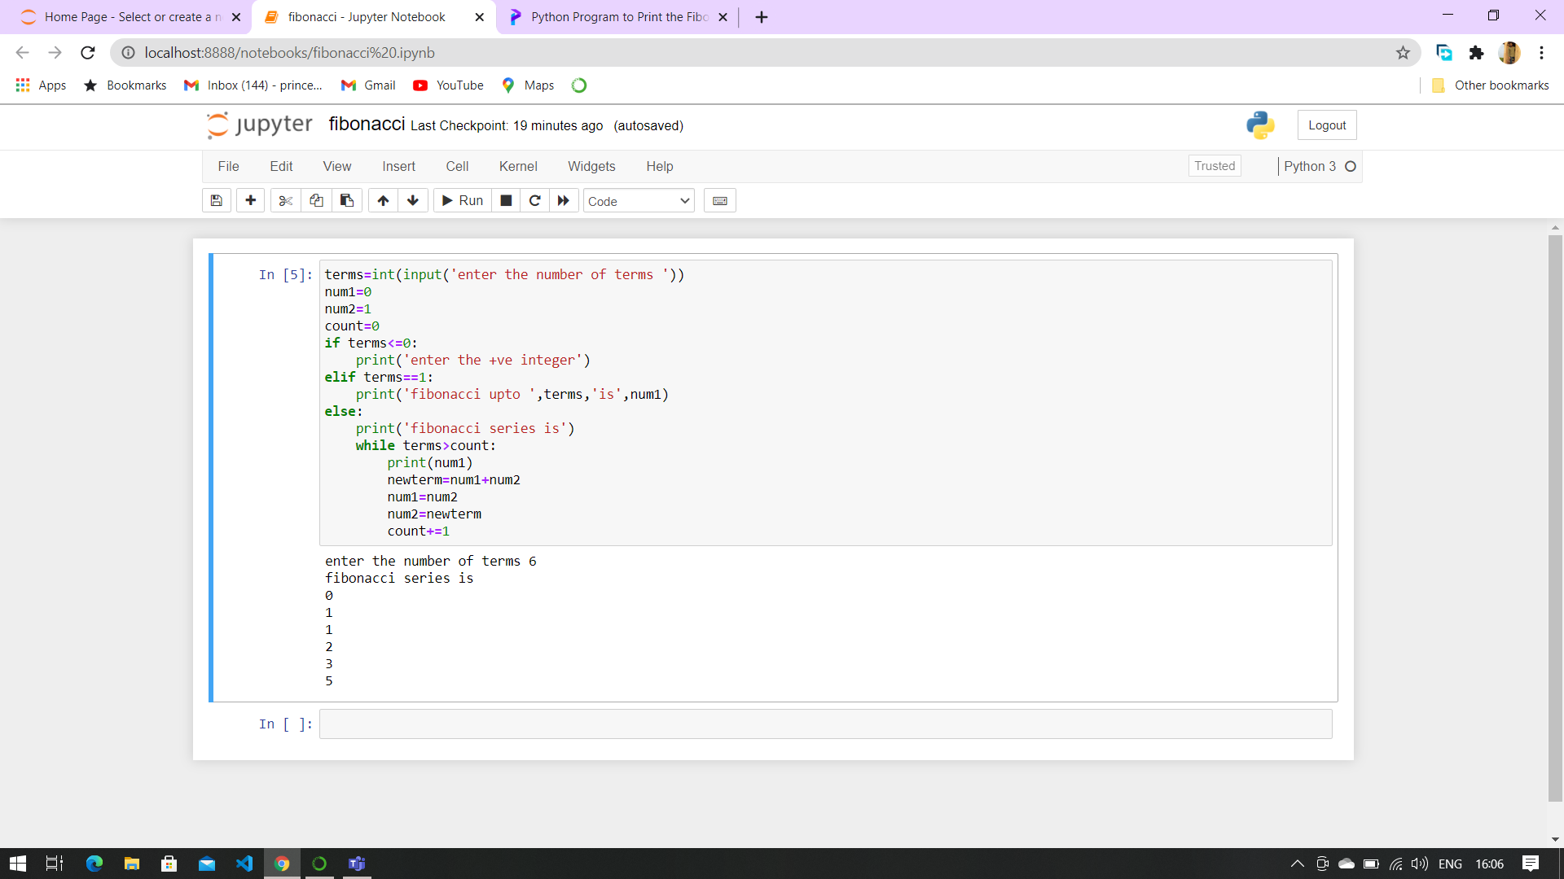1 1 2 3 5 8 13

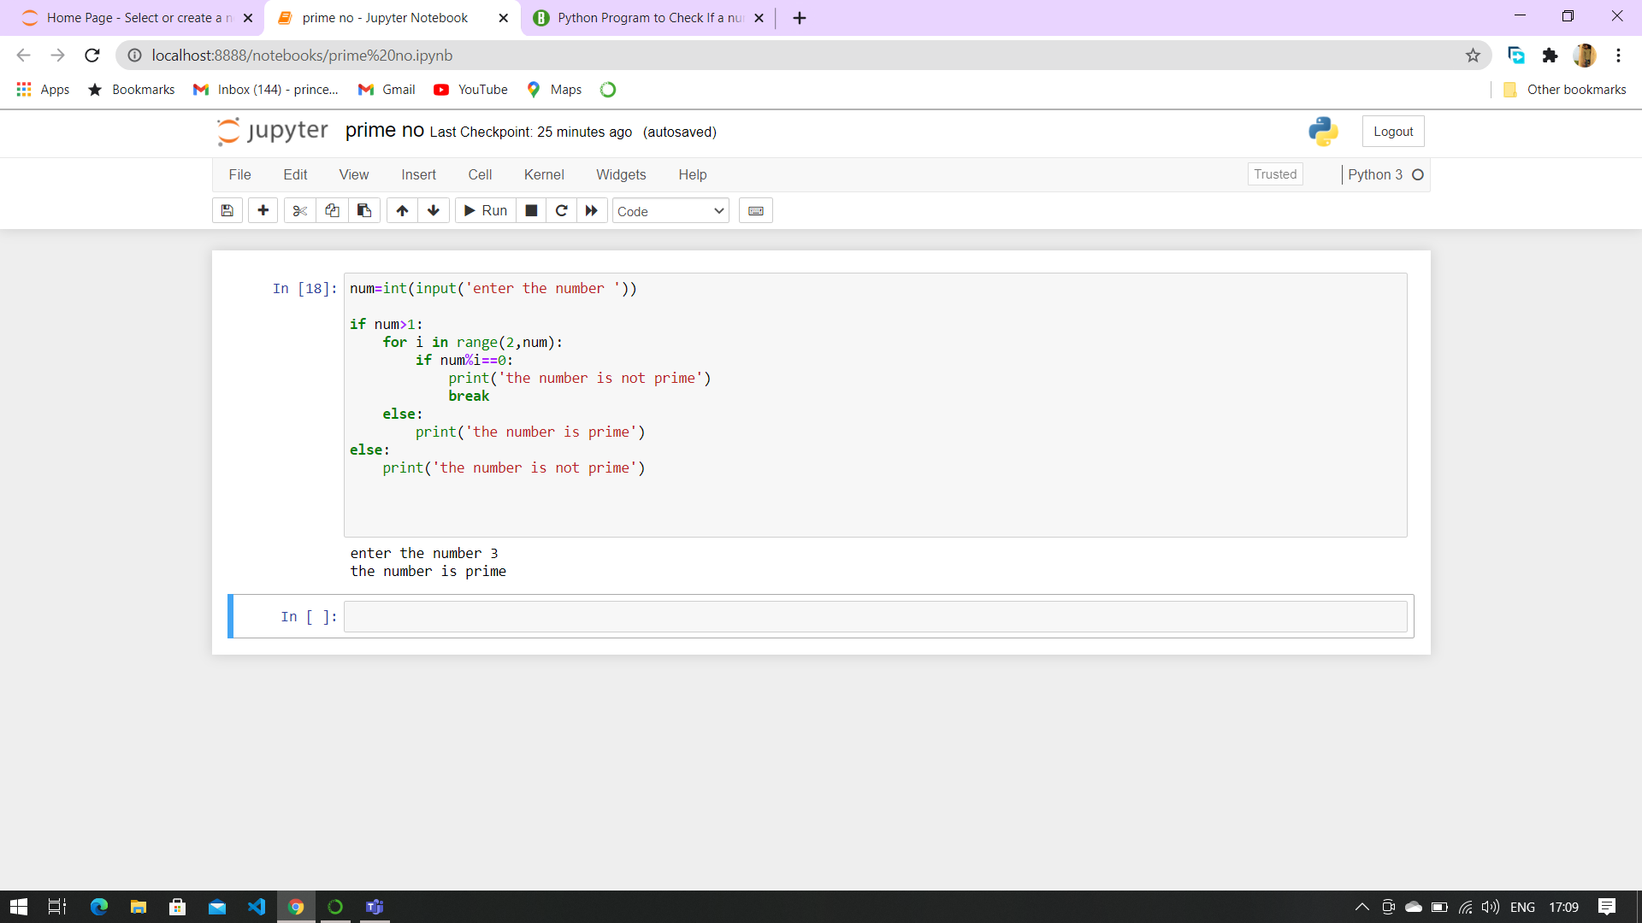8.[Check whether a number is prime or not](https://www.programiz.com/python-programming/examples/prime-number)

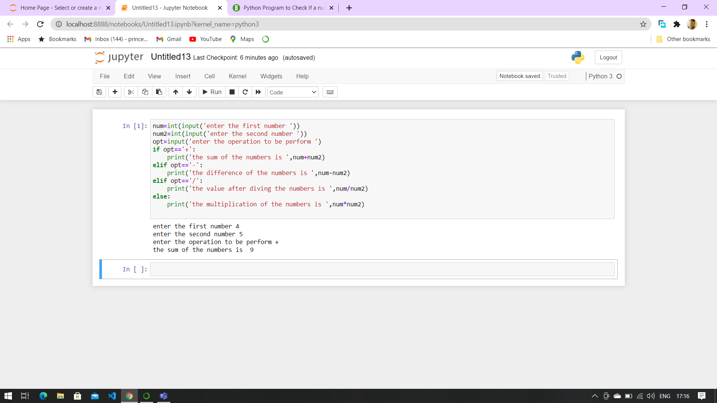9.[Make a Simple Calculator](https://www.programiz.com/python-programming/examples/calculator).